# GOVERNMENTARTSANDSCIENCECOLLEGE



19,poonthotamstreet,thiruvottiyur,chennai-600019

## INSIGHSTREAM:NavigateTheNewsLandscape

**(ReactApplication)**

PROJECTREPORT

## SubmittedInPartial FulfilmentForTheAwardOf

BATCHELOROFCOMPUTERAPPLICATION

By

S.RADHA(TL)(212205686) S.JANANI(212205671) A.JEEVITHA(212205672) S.KAVIYA(212205676) V.MADHUMITHA(212205679)

# April 2025

**Introduction:**

**INSIGHSTREAM:NavigateTheNewsLandscape(React**

**Application**

InsightStream is a revolutionary web application designed to redefine how people discover andconsumenews.Itoffersanintuitiveinterface,dynamicsearch,andavastrangeofnews categoriesforalltypes ofusers.JoinInsightStreamtoembark onaninformativejourney and experience the future of news consumption.

### Description:

🌐 Welcome to the cutting-edge frontier of news exploration with InsightStream! Our revolutionary web application is meticulously crafted to transcend the boundaries of traditionalnewsconsumption,cateringtothediverseinterestsofbothavidnewsenthusiasts andseasonedinformationprofessionals.Withanemphasisonanintuitiveuserinterfaceand a robust feature set, InsightStream is poised to redefine the entire news discovery and consumption process.

📰Designedwithacommitmenttouser-friendlyaesthetics,InsightStreamimmersesusersin an unparalleled journalistic adventure. Navigate seamlessly through a vast expanse of news categorieswithfeaturessuchasdynamicsearch,effortlesslybringingyouthelatestandmost relevant stories from around the world.

🌍 From those seeking the latest headlines to seasoned news connoisseurs, InsightStream embracesadiverseaudience,fosteringadynamiccommunityunitedbyasharedpassionfor stayinginformed.Ourvisionistoreshapehowusersinteractwithnews,presentingaplatform that not only delivers breaking stories but also encourages collaboration and sharing within the vibrant news community.

📡Embarkonthisinformativejourneywithus,whereinnovationseamlesslyintertwineswith journalistictradition.Every click within InsightStream propels youcloser toarealm of global happenings and perspectives. Join us and experience the evolution of news consumption, where each feature is meticulously crafted to offer a glimpse into the future of staying informed.

🌐 Elevate your news exploration with InsightStream, where every headline becomes a gateway to a world of information waiting to be discovered and understood. Trust InsightStream to be your reliable companion on the journey of staying connected with the pulse of the world.

## ScenarioBasedIntro:

Suppose you're rushing home after work, phone clutched in your hand. Today's been a whirlwind, and you have no idea what's happening in the world.Suddenly, you remember InsightStream,theinnovativeappyoudownloadedthatpromisedtorevolutionizeyournews experience.Intrigued,youopentheapp.Imagesflashacrossthescreen–breakingheadlines, in-depth articles, diverse categories.This isn't your typical news feed.InsightStream feels...different.Intrigued, you tap a category and dive in, ready to explore the future of staying informed.

## TechnicalArchitecture:

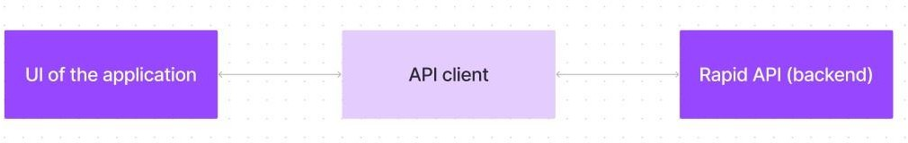

The user experience starts with the InsightStream web application's UI, likely built with a frameworklikeReactorVue.jsforasmooth,single-pageexperience.ThisUIinteractswithan APIclientspecificallydesignedforInsightStream.Thisclienthandlescommunicationwiththe backend, but with a twist: it leverages Rapid API, a platform providing access to various external APIs. This suggests InsightStream might integrate external data feeds or functionalities throughRapidAPI, enriching the user experience without building everything from scratch.

## ProjectGoalsandObjectives:

The primary objective of InsightStream is to establish a user-friendly platform tailored for individuals who are passionate about staying informed, exploring diverse news topics, and accessing the latest updates.

Ourkeygoalsinclude:

✔**User-Friendly Experience:** Develop an interfacethatis intuitive and easyto navigate, ensuring users can effortlessly access, save, and share their preferred news articles.

✔ **Comprehensive News Management:** Provide robust features for organizing and managing news content, incorporating advanced search options for a personalized news experience.

✔ **Technology Stack:** Employ cutting-edge web development technologies, such as React.js, to ensure an efficient and enjoyable user interface.

## FeaturesofInsightStream:

✔ **News from API Sources:** Access a vast library of global news spanning various categories and interests, ensuring a well-rounded coverage of current affairs.

✔ **Visual News Exploration:** Discover breaking stories and explore different news categories through curated image galleries, enhancing the visual appeal of news discovery.

✔ **Intuitive Design:** Navigate the application seamlessly with a clean, modern interface designed for optimal user experience and clarity in information presentation.

✔ **Advanced Search Feature:** Easily access news articles on specific topics through a powerful search feature, providing users with tailored news content based on their interests.

#### PRE-REQUISITES:

HerearethekeyprerequisitesfordevelopingafrontendapplicationusingReact.js:

#### ✔Node.jsandnpm:

Node.jsisapowerfulJavaScriptruntimeenvironmentthatallowsyoutorunJavaScript codeonthelocalenvironment.Itprovidesascalableandefficientplatformforbuilding network applications.

Install Node.js and npm on your development machine, as they are required to run JavaScript on the server-side.

* Download:<https://nodejs.org/en/download/>
* Installationinstructions:<https://nodejs.org/en/download/package-manager/>

✔**React.js**:

React.js is a popular JavaScript library for building user interfaces. It enables developerstocreateinteractiveandreusableUIcomponents,makingiteasiertobuild dynamic and responsive web applications.

InstallReact.js,aJavaScriptlibraryforbuildinguserinterfaces.

* CreateanewReactapp:

npxcreate-react-appmy-react-app

Replacemy-react-appwithyourpreferredprojectname.

* Navigatetotheprojectdirectory

cdmy-react-app

* RunningtheReactApp:

WiththeReactappcreated,youcannowstartthedevelopmentserverandsee your React application in action.

* Startthedevelopmentserver:

npmstart

This command launches the development server, and you can access your React app at [http://localhost:3000](http://localhost:3000/)in your web browser.

✔**HTML,CSS,andJavaScript**:BasicknowledgeofHTMLforcreatingthestructureofyour app, CSS for styling, and JavaScript for client-side interactivity is essential.

✔ **Version Control**: Use Git for version control, enabling collaboration and tracking changesthroughoutthedevelopmentprocess.PlatformslikeGitHuborBitbucketcan host your repository.

* + Git: Downloadand installation instructions canbefoundat: <https://git-scm.com/downloads>

✔ **Development Environment**: Choose a code editor or Integrated Development Environment (IDE) that suits your preferences, such as Visual Studio Code, Sublime Text, or WebStorm.

* VisualStudioCode:Downloadfrom<https://code.visualstudio.com/download>
* SublimeText:Downloadfrom<https://www.sublimetext.com/download>
* WebStorm:Downloadfrom<https://www.jetbrains.com/webstorm/download>

ToinstallandruntheApplicationprojectfromgoogledrive: Follow below steps:

#### ✔Get thecode:

* Downloadthecodefromthedrivelinkgivenbelow: <https://github.com/asunm1011010unm1011010212205679/Newsapp.git>

#### InstallDependencies:

* Navigateintotheclonedrepositorydirectoryandinstalllibraries:

cdnews-app-react npm install

#### ✔StarttheDevelopment Server:

* + Tostartthedevelopmentserver,executethefollowingcommand:

npmstart

#### AccesstheApp:

* + Openyourwebbrowserandnavigateto[http://localhost:3000.](http://localhost:3000/)
  + Youshouldseetheapplicationshomepage,indicatingthattheinstallation and setup were successful.

Youhavesuccessfullyinstalledandsetuptheapplicationonyourlocalmachine.Youcannow proceed with further customization, development, and testing as needed.

### Projectstructure:

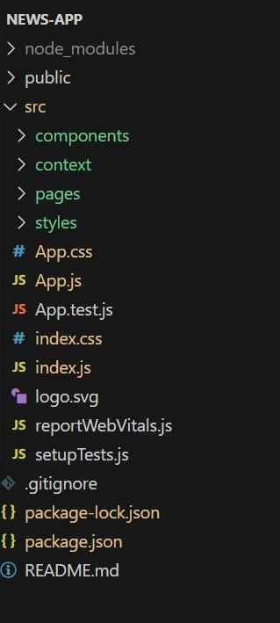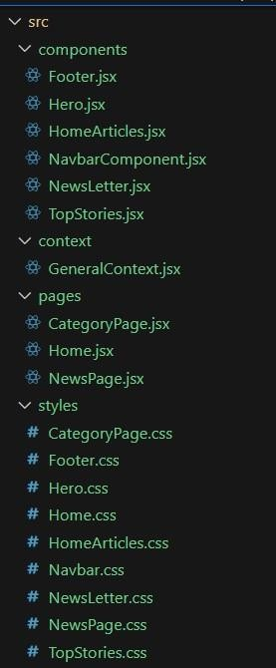

In this project, we’ve split the files into 4 major folders, *Components, Context, Pages and Styles.* In the pages folder, we store the files that acts as pages at different URLs in the application.The components folder stores all the files, that returns the small components in theapplication.ThecontextApiwillbecodedinthecontextfolder.Allthestylingcssfileswill be stored in the styles folder.

### ProjectFlow:

#### Projectdemo:

Beforestartingtoworkonthisproject,let’sseethedemo.

Demolink:<https://drive.google.com/file/d/1i8y09FiMk7QM0akH3my10OBWqXH-8dNh/view?usp=sharing>Use

thecodein:

<https://drive.google.com/drive/folders/1tDoSwd-1I3HsPJ9_92MnZTUtteeda-hL?usp=sharing>

**Milestone1:Projectsetupandconfiguration.**

#### Installationofrequiredtools:

To build InsightStream, we'll need a developer's toolkit. We'll use React.js for theinteractiveinterface,ReactRouterDomforseamlessnavigation,andAxiostofetch news data.For visual design, we'll choose either Bootstrap or Tailwind CSS for pre- built styles and icons.

Opentheprojectfoldertoinstallnecessarytools.Inthisproject,we use:

OReactJs

OReactRouterDom OReact Icons

OBootstrap/tailwindcss OAxios

* Forfurtherreference,usethefollowingresources

o<https://react.dev/learn/installation>

o<https://react-bootstrap-v4.netlify.app/getting-started/introduction/>

o<https://axios-http.com/docs/intro>

o<https://reactrouter.com/en/main/start/tutorial>

**Milestone2:ProjectDevelopment**

* SetuptheRoutingpaths

Setuptheclearroutingpathstoaccessvariousfilesintheapplication.

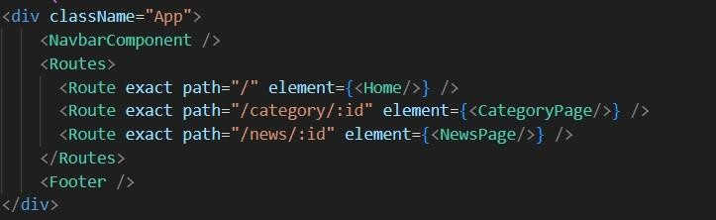

* DeveloptheNavbarandHerocomponents
* Codethepopularcategoriescomponentsandfetchthecategoriesfrom***newsapi***.
* Also,addthetrendingnewsinthehomepage.
* Additionally,wecanaddthecomponenttosubscribeforthenewsletterandthefooter.
* Now, develop the category page to display various news articles under the different categories.

#### ImportantCodesnips:

❔**FetchingTop/Trendingnews**

WiththeAPIrequest,wefetchthetrendingnewsarticles.

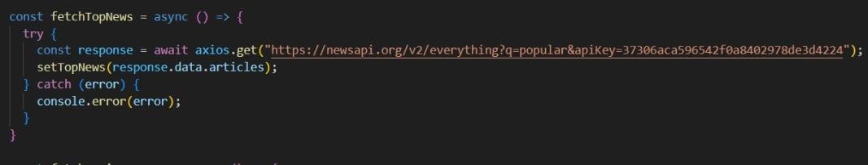

ThecodesnippetshowsafunctionwritteninPythoncalledfetchTopNewsthatfetches news articles from an API. Here's a breakdown of the code:

*AsyncfunctionfetchTopNews:*

The code defines an asynchronous function named fetchTopNews. An asynchronousfunctionisusedtohandleasynchronousoperations,suchasmakingAPI requests that take time to complete.

*try...catchblock:*

* + Thetry...catchblockisusedtohandletheAPIrequest.
  + ThetryblockcontainsthecodethatattemptstofetchdatafromtheAPIusing axios.get.
  + axios is an external Python library for making HTTP requests. If you don't already use Axios in your project, you'll need to install it using a package manager like pip.
  + The.getmethodmakesaGETrequesttothespecifiedURL.

***APIURL:***

#### TheURLusedin theAPIrequest is

['https://newsapi.org/v2/everything?q=popular&apiKey=37306aca596542f0a8402978de3d4224'](https://newsapi.org/v2/everything?q=popular&apiKey=37306aca596542f0a8402978de3d4224).

ThisislikelyaspecificAPIendpointthatreturnspopularnewsarticles.Youmightneed to replace this URL with the actual endpoint you want to use depending on the API you're using. Replace '37306aca596542f0a8402978de3d4224' with a placeholder instructing users to replace it with their own API key.

*ErrorHandling(catchblock):*

The catchblock handles any errors thatmightoccur during the APIrequest.If there's an error, it's logged to the console using console.error(error).

*SettingState(thenblocknotshown):*

The.thenmethod(notshowninthecodesnippet)islikelyusedtoprocessthefetched data after a successful API request.

In this case, it likely updates a state variable named topNews (based on the function namefetchTopNews)withthefetchednewsarticles.Thisstatevariablemightbeused to display the news articles in a user interface.

#### ?Fetchingnewsby search/category

With the specific category or search keyword, we use API request to fetch all the news articles related to that.

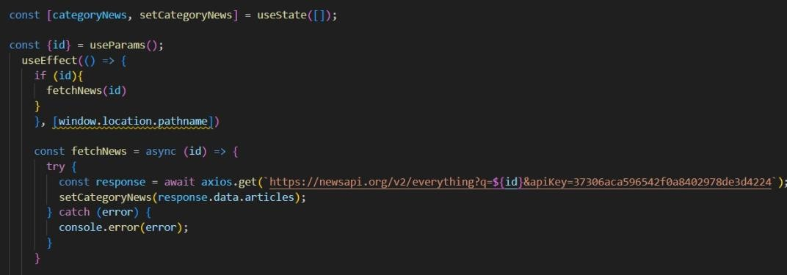

Thecodesnippetshowsafunctioncalledget_news_articlesthatfetchesnewsarticles from a news API. Here's a breakdown of the code:

*Imports:*

The code starts by importing the requests library. The requests library is a popular Pythonlibrary for making HTTP requests.If youdon't already have itinstalledinyour project, you can install it using pip install requests.

*APIKey:*

ThelineAPI_KEY='YOUR_API_KEY'definesavariablenamedAPI_KEYandassignsita placeholder value 'YOUR_API_KEY'. You should replace this with a placeholder instructing users to replace it with their own API key obtained from the news API provider they want to use.

*FunctionDefinition(get_news_articles):*

Thecodedefinesafunctionnamedget_news_articlesthattakestwoparameters:

* + query:Thisparameterislikelyastringrepresentingthesearchqueryfornews articles.
  + source:Thisparameterislikelyastringrepresentingthenewssource(e.g., 'bbc-news', 'cnn').

*BuildingtheAPIRequestURL:*

Thelineurl=f'https://newsapi.org/v2/everything?q={query}sapiKey={API_KEY}' constructstheURLfortheAPIrequestusingaformattedstringliteral(f-string).

TheURLincludesthefollowingparts:

* + BaseURL:https://newsapi.org/v2/everything
  + Queryparameters:
  + q:Thisparameterissettothequeryargumentpassedtothefunction.
  + apiKey:ThisparameterissettotheAPI_KEYvariable,whichshouldcontainthe user's API key.

*MakingtheAPIRequest(requests.get):*

Thelineresponse=requests.get(url)sendsaGETrequesttotheAPIURLconstructed earlier.Therequests.getfunctionfromtherequestslibraryisusedtomaketheHTTP request. The response from the API is stored in the response variable.

*ErrorHandling(try...exceptblock):*

* + Thetry...exceptblockisusedtohandlepotentialerrorsduringtheAPIrequest.
  + ThetryblockcontainsthecodethatattemptstofetchdatafromtheAPIusing requests.get(url).
  + Theexceptblock handlesanyexceptionsthatmight occurduringthe request, such as network errors or invalidAPI responses.In this case, it prints anerror message to the console using print(f'Error fetching news articles: {e}').

### ProjectExecution:

After completing the code, run the react application by using the command “npm start” or “npm run dev” if you are using vite.js

Herearesomeofthescreenshotsoftheapplication.

#### ?Hero components

In the hero component, the trending newsarticlesare displayed. It isto highlight them.Apartfromthat,thesearchbarisalsoavailabletosearchforvariousarticles and categories.

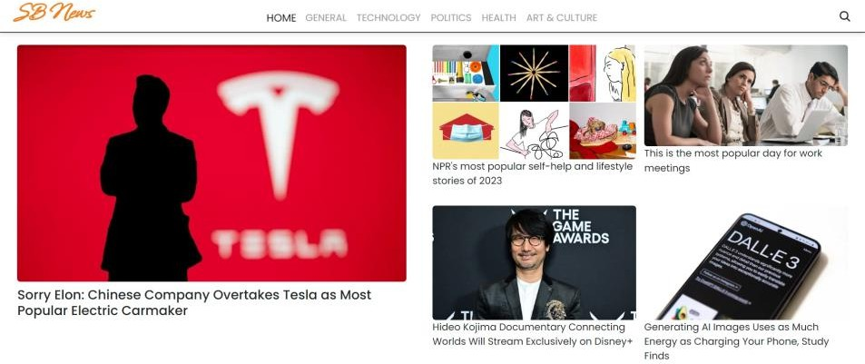

#### ?Popular categories

In the hero component, the trending news articles are displayed. It is to highlight them. Apart from that, the search bar is also available to search for various articles and categories.

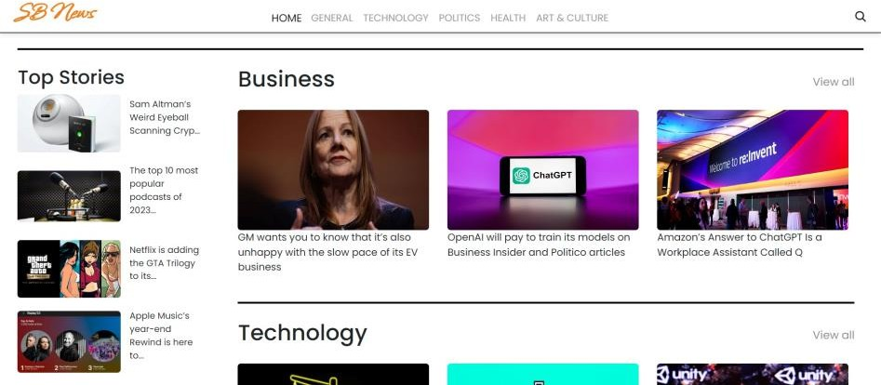

#### ?Newsletter

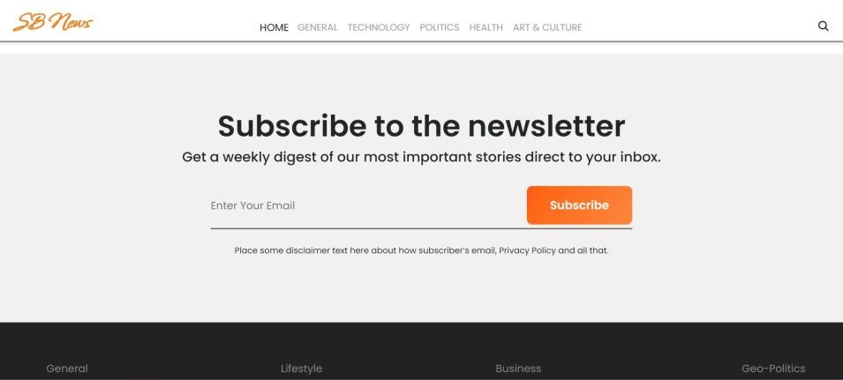Stayinginformediskey!Thissectionwouldactasamagnetforuserswhowantto stay up-to-date onthe latest news.A brief signupformwithanemail fieldwould bepresented,alongwithaclearcalltoactionbuttonlike"SubscribeNow"or"Get Daily News Updates."With a simple click, users can join the InsightStream community and receive curated news delivered straight to their inbox.

#### ?Category/Searchresultpage

Finding the news you crave is effortless with InsightStream.This page displays a neatly organized list of articles matching your chosen category or specific search query.Each entry would provide a clear headline, a concise summary, and if available, an image to give you a quick glimpse into the story.To further refine yourexploration,filtersorsortingoptionsmightbeavailable.Imaginenarrowing

downresultsbydate,source,keyword,orotherrelevantcriteriatopinpoint exactly what you're looking for.

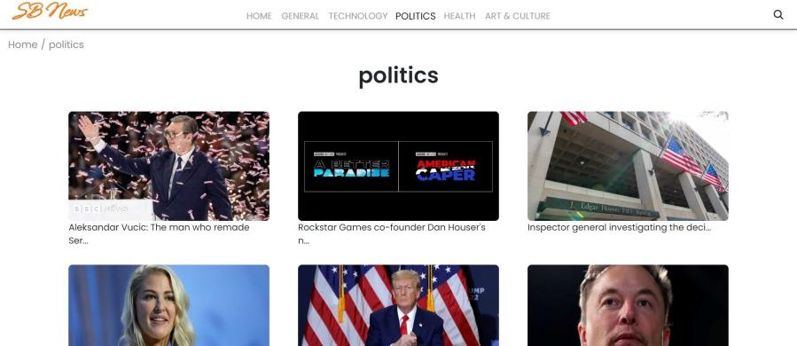

#### ?RedirectedArticlepage

Thisiswhereyoudivedeep!Thearticlepageproudlydisplaysthecompletenews story, retrieved directly from the original source.To keep you engaged and exploring relatedtopics, the page might also suggest additional articles based on thecurrentstory.Thesesuggestionscanopendoorstoaworldofinterconnected information, allowing you to become a well-rounded news connoisseur.



#### Conclusion

In conclusion, navigating the newslandscape for a news app requires a strategic approach to both content curation and user engagement. With the rapid evolution of digital media, news appsmustprioritizereal-timeupdates,crediblesourcing,andpersonalizedexperiencestokeep usersinformedandengaged.Additionally,integratinginteractivefeatures,suchasnotifications, comments, and social sharing, can help build a more connected and loyal user base. By

embracingtheseelements,newsappscansuccessfullyadapttothechangingmedia

environment,fostertrust,andenhancetheirvaluepropositiontousersinanincreasingly competitive space.

ProjectDemolink:

<https://drive.google.com/file/d/10j0Ga63dZDfkNzLJKKTk9QC0s0sRglQh/view?usp=drivesdk>